Valve Adjustment
The tools needed and the technical information available make this a dang good DIY project.
You only need a set of feeler guages and a 10mm wrench to do it.
More and fancier are nice but many a valve has been gauged by a $2 feeler gauge from a hardware store.
Let see if we can set up a step by step of a m30 valve adjustment.
If it is a manual transmission the movement of the engine is easier, you can leave the car in gear and on a flat surface just knudge the car, with a knee, to get the engine to turn.
If automatic you can use the diagnostic plug and with a wire connect the starter solenoid to get movement.
After removing the valve cover, all 10mm nuts.
You will see two valves for every cylinder.
Here is a picture from a m10 so the gap is different but the rocker is the same.
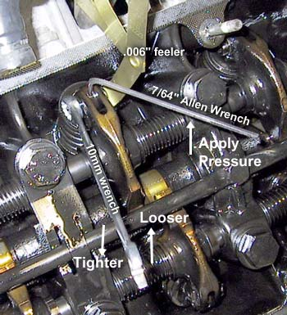
Make sure all the valves are set equally at
a go .013 / no go .014
Always measure at the Valve to the eccentric for clearance.
Remember when setting the valves to make sure the piston is at TDC on the valves you are adjusting. This occurs when the cam lobes are both pointing down equally.
You can use a socket on the crankshaft bolt.
On Manual transmissions, on level ground, you can put transmission in 3 gear, and by rolling the car rotate the engine.
On the Diag. plug you can provide power to the pin #11.
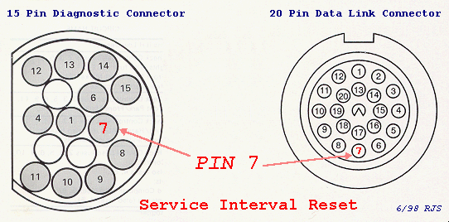
Also you can use the cam in X then the mated cylinder is in TDC.
First thing to do is to make sure the car has completely cooled down
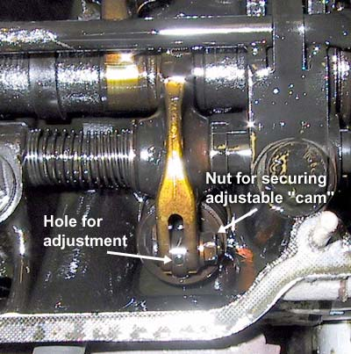
As you begin to tighten the nut, keep a steady light pressure on the Allen Wrench (or similar device) since the adjustment cam may want to rotate. Also keep in mind that as you are tightening with one hand, the other hand may want to put extra or not enough pressure on the cam. Try to keep a steady amount of pressure.
The main goal is to tighten it ENOUGH.
Valve cover 9+-1 Nm or SAE 80+-9 in-lb
Valve eccentrics 10+-1 Nm or SAE 89+-9 in-lb
Follow the same procedure with the other ones.
You can use a socket on the crankshaft bolt.
On cars with standard transmissions you can put it in 3rd gear and rock the car to get the engine to the correct position.
On those with a diagnostic plug you can use pin 11 and the jumper there.
Always do it twice, once to set and next to check.
Banjo Bolts
In the head, on top of the cam, there is an oil sprayer bar that directs oil to lubricate the cam and rockers. The oil spray bar bolts are hollow bolts through which oil passes through, into the oil sprayer bar. Now, these bolts tend to come loose in time from vibration. This can happen in as little as 20k miles, or as long as 150k miles, there is really no "set" mileage that this happens.
BMW has issued a new bolt to fix this problem. Really, what it is is the same bolt with a tad of locktite on the threads. But it is a new partnumber and the old bolt (with no blue locktite) and the new bolt are differentiated by a round circle engraved in the head of the new bolt. The part number for these bolts is 11 42 1 738 621.
Any good (i.e. knowledgable) BMW mechanic should know about this problem on M30s. And whenever you get a valve adjustment (which should be every 15k miles or 1-2 years), the mechanic should check the torque on those bolts. So long as you do that, you should have no problem. Even with the "old" bolts.

